# **23. ETHERCHANNEL**

## **What is EtherChannel?**

EtherChannel allows you to **group multiple physical interfaces into a single logical interface**, enabling them to operate as one.

* **Layer 2 EtherChannel**: Groups switch ports to behave as a single interface.
* **Layer 3 EtherChannel**: Groups routed ports to behave as a single interface, with an IP address assigned.

### **Key Concept: Oversubscription**

When the bandwidth of interfaces connected to end hosts exceeds the connection to the distribution switches, it's called **oversubscription**.

* Some oversubscription is acceptable, but excessive amounts can cause congestion.

## **Why Use EtherChannel?**

If two switches are connected with multiple links:

* **Spanning Tree Protocol (STP)** disables all except one link to prevent Layer 2 loops, which can cause broadcast storms.
* With EtherChannel, all links in the group act as a **single interface** for STP, allowing **all interfaces to remain active**.

### **Benefits of EtherChannel**

1. Groups multiple channels into one logical interface.
2. Enables **load balancing** of traffic across physical interfaces.
3. Simplifies configuration and improves redundancy.

## **How Does EtherChannel Load Balance?**

EtherChannel balances traffic using **flows**:

* A “flow” represents communication between two nodes in the network.
* Frames in the same flow use the **same physical interface** to ensure frames arrive in order.

### **Inputs for Load Balancing**

Load balancing can be configured based on:

* **Source MAC Address**
* **Destination MAC Address**
* **Source and Destination MAC Address**
* **Source IP Address**
* **Destination IP Address**
* **Source and Destination IP Address**

### **Key Commands**

To view the load-balancing method:  
ASW1# show etherchannel load-balance

To configure the load-balancing method:  
 ASW1(config)port-channel load-balance [mode] -> e.g. src-dst-mac

## **EtherChannel Configuration**

There are **three methods** to configure EtherChannel:

ASW1(config-if-range)#channel-protocol ?

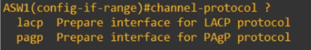

### **1. PAgP (Port Aggregation Protocol)**

* **Cisco proprietary protocol**.
* Dynamically negotiates the creation/maintenance of EtherChannel.
* Modes:
  + **Auto**: Passive mode, waits for negotiation.
  + **Desirable**: Actively initiates negotiation.

#### 

#### **Example:**

ASW1(config-if-range)#channel-group 1 mode desirable

### **2. LACP (Link Aggregation Control Protocol) -> Preferred**

* **Industry standard protocol** (IEEE 802.3ad).
* Dynamically negotiates the creation/maintenance of EtherChannel.
* Modes:
  + **Active**: Actively negotiates.
  + **Passive**: Waits for negotiation.

#### **Example:**

ASW1(config-if-range)#channel-group 1 mode active

### **3. Static EtherChannel**

* Interfaces are **statically configured** to form an EtherChannel.
* **No protocol** is used for negotiation.
* Mode:
  + **On**: Forces the interface into EtherChannel mode.

#### **Example:**

ASW1(config-if-range)#channel-group 1 mode on

## **Important Notes for Configuration**

* **All member interfaces** must have matching configurations:
  + Duplex (full/half)
  + Speed
  + Switchport mode (Access/Trunk)
  + Allowed VLANs/Native VLAN (for trunks)
* Mismatched configurations will exclude the interface from EtherChannel.

## **Verification Commands**

**Summary of EtherChannel Status**:  
  
 ASW1#show etherchannel summary

* + Flags:
    - S: Layer 2 EtherChannel
    - R: Layer 3 EtherChannel
    - U: In Use
    - D: Down
    - P: Bundled in port-channel
    - s: Suspended

**Detailed Port-Channel Information**:  
  
 ASW1#show etherchannel port-channel

**Spanning Tree View of EtherChannel**:  
  
 ASW1#show spanning-tree

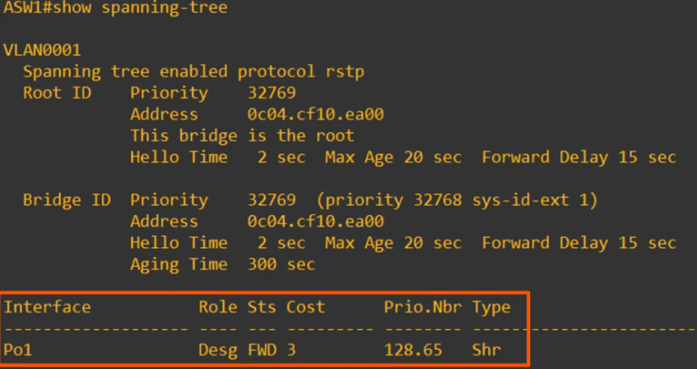

No worries of Layer 2 loops

## **Layer 3 EtherChannel**

### **Configuration Steps**

Remove the switchport command to make interfaces Layer 3.  
 ASW1(config-if-range)#no switchport

Assign an IP address directly to the **Port-Channel** interface.  
 interface Port-channel1

ASW1(config-if-range)#int po1

ASW1(config-if)#ip address 192.168.1.1 255.255.255.0

### **Verification**

View configuration:  
 ASW1#show running-config

View Layer 3 EtherChannel status:  
 ASW1# show etherchannel summary

## **Commands Summary**

SW(config)port-channel load-balance [mode] # Configures load balancing

SW#show etherchannel load-balance # Displays load-balancing settings

SW#(config-if)channel-group [number] mode # Configures EtherChannel mode

SW#show etherchannel summary # Summarizes EtherChannel status

SW#show etherchannel port-channel # Shows detailed port-channel info

SW#show spanning-tree # Displays STP EtherChannel details